**PRACTICAL 10**

**AIM : CART**

**INPUT(CLASSIFICATION):**

# Importing necessary libraries  
from sklearn.tree import DecisionTreeClassifier  
from sklearn.model_selection import train_test_split  
from sklearn.metrics import accuracy_score  
from sklearn.datasets import load_iris  
  
# Load the Iris dataset (classification example)  
iris = load_iris()  
X = iris.data  
y = iris.target  
  
# Split the dataset into training and testing sets  
X_train, X_test, y_train, y_test = train_test_split(X, y, test_size=0.2, random_state=42)  
  
# Create a CART model (Decision Tree for classification)  
cart_classifier = DecisionTreeClassifier(criterion='gini', random_state=42)  
  
# Train the classifier  
cart_classifier.fit(X_train, y_train)  
  
# Make predictions on the test set  
y_pred = cart_classifier.predict(X_test)  
  
# Evaluate the model's performance  
accuracy = accuracy_score(y_test, y_pred)  
print(f'Classification Accuracy: {accuracy:.4f}')

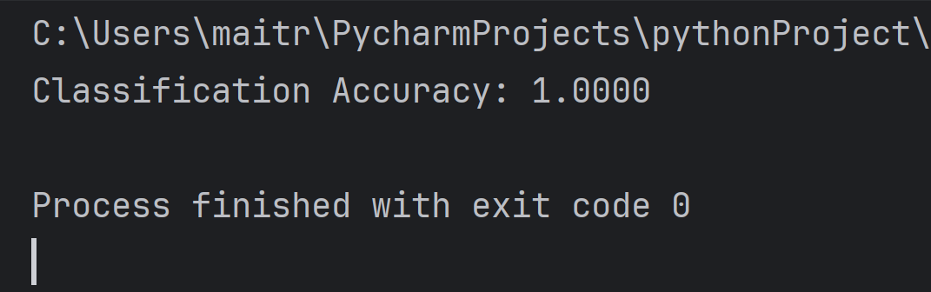**OUTPUT:**